Fictional Learning Power Stories

You may find these Learning Power stories interesting to read.
They’re not real people, but are based on many real students.
The stories demonstrate some of the reasons that can contribute to a profile having the shape it does.
If your story shares some similarities with one or more of these stories, then they might help you reflect on your own Learning Power.

Historical Note:
“CLARA” is the former name for the spider diagram, just ignore that! It’s the same profile that you use in the Learning Journeys website.

Courtney’s Learning Power Profile
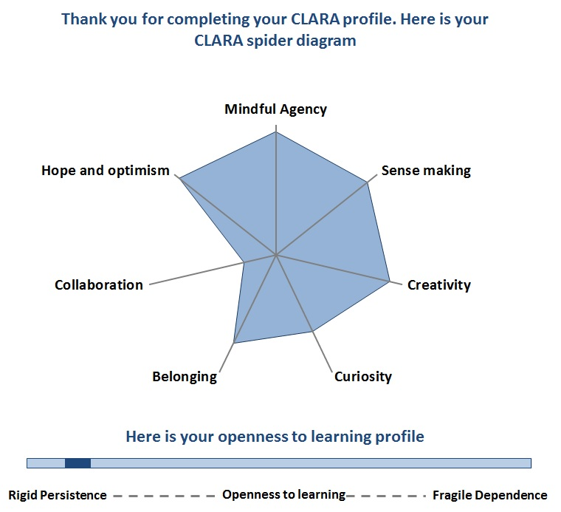

Courtney is very intelligent and was often bored at school. She comes from an upper middle class family in North Sydney. Her Dad was a politician and she didn’t see him much. He’s not particularly interested in her studies or how she’s getting on but he does want her to succeed at Uni. Courtney is not close to her mother and has no siblings. Her parents are divorced after an acrimonious divorce settlement.
Courtney is ambitious at Uni and wants to get ahead. She recognises that good grades are her ticket to a future career. She is doing a nursing degree and plans to move into medicine later. She’s getting good grades but she hates group work because she always feels like she’s carrying the others. She really dislikes receiving negative feedback on her assignments and hates to fail – her father has always said that failure shouldn’t be in her vocabulary. She has a large group of friends on Facebook, both male and female, and a smaller group she interacts with regularly. She enjoys being able to help her friends, even lending them money when they need it and organising events, but she does her studying alone. She’s had boyfriends but she often breaks off the relationship because it doesn’t meet her needs.
NOTES

Dale’s Learning Power Profile
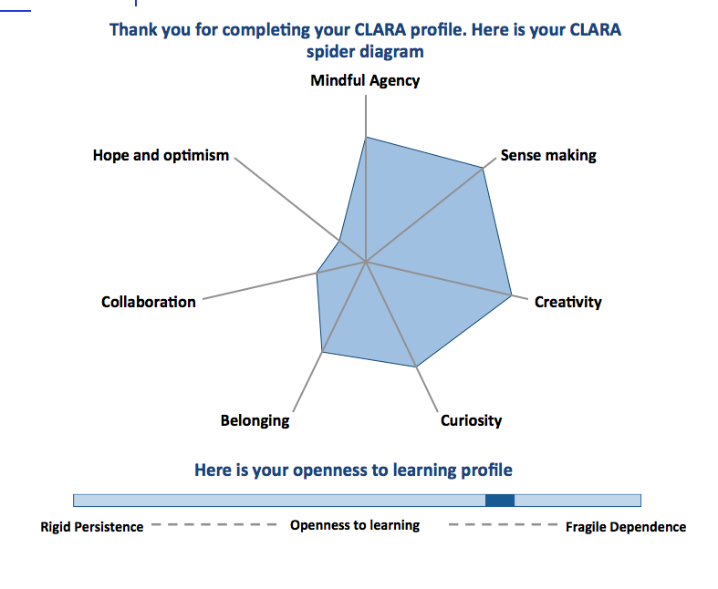
Dale is the first in his family to go to University. His high school teachers encouraged him to consider enrolling in a nursing degree because he always enthusiastic about science at school and nursing is applied science. He’s really smart and is passionate about biology but now that he’s at Uni, he’s not sure that he belongs here because most of his friends are not doing tertiary studies. His parents want him to get a ‘proper job’ and earn some money to secure his future.
He’s really creative – he plays the guitar and loves surfing. He loves the idea of being a nurse but he’s not sure of his abilities and lacks self-confidence. He loves the teaching and lectures and he would be getting very good grades but his parents kicked him out of home and so he’s now trying to earn money to pay rent and buy groceries, which is causing his grades to drop. He has friends – but none of his friends from last year go to University so he doesn’t feel able to talk to them about his Uni problems. In fact he doesn’t feel able to talk to anyone – he thinks that talking to other people is a sign of weakness and you shouldn’t share your problems with other people. He feels stuck and hopeless.
When he is able to come to class regularly, Dale is really good at putting concepts together from lectures and readings and he has little problem in making sense of the material. He doesn’t accept things at face value and wants to understand things in more depth. He’s good at identifying where his learning fits in the bigger picture and constructing broader knowledge by piecing individual concepts together. He’s not comfortable learning in groups because he doesn’t feel confident in putting his ideas forward.

NOTES

Hongyan’s Learning Power Profile

Hongyan moved to Australia from abroad last year. Her parents want her to go to University and be a nursing student so that she can get a respected job and earn a good wage. She is an only child but she is very sociable and has many friends. Her parents have worked really hard to get her here so she feels under pressure make sure she does well at Uni.
She’s a very hard worker – she always got good grades at High School. She diligently listens to what the teacher says and does exactly what she thinks is expected of her but her grades haven’t been as good as she hoped. When she is faced with an open-ended question or a problem that doesn’t have a single right answer she panics and doesn’t know how to proceed. If there are rules to follow she is comfortable in her learning but when faced with complexity and uncertainty she gets confused and feels ‘groundless’.
In class she nearly always sits with her other Chinese student friends and feels a strong sense of belonging to her cultural community. She likes learning with her friends and they will test each other in remembering names and medications. She has a strong drive to please others and do well.

NOTES

James’ Learning Power Profile

James has a quirky personality that not everybody understands. His sister and parents love him dearly and when you get to know him he can be quite funny as well. He comes from a middle class family, fourth generation Australian originally from Italy. He did well at school particularly at Maths and Chemistry but selected a nursing degree because of his recent interest in health. His English and writing are not his strength but he gets by.
At Uni James is doing OK. He’s doing best in the science subjects but the people subjects are more of a challenge. He can understand and develop some very complex scientific problems but when it comes to understanding their application in a wider context he struggles. He enjoys being with other people at Uni but has no core group of friends and doesn’t understand why sometimes his friends don’t want to talk with him or socialise very much. He sometimes notices this in class as well – during tutorials and group work he finds it hard to understand what’s going on.

NOTES

Mohammed’s Learning Power Profile
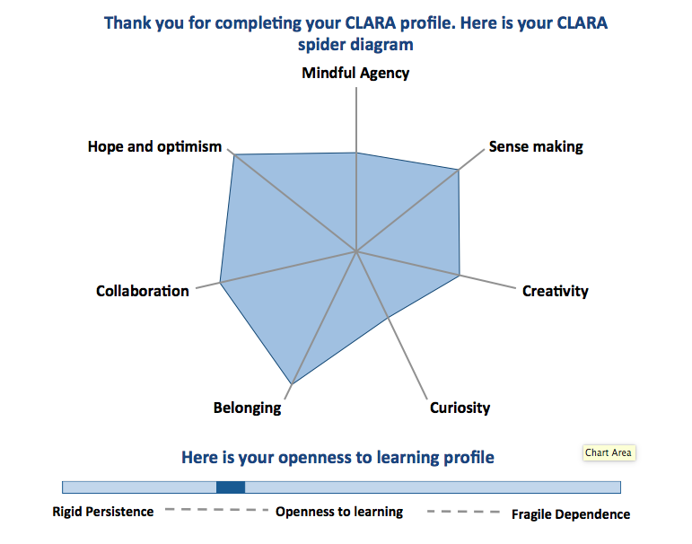

Mohammed is a hard working young man from a large family. His parents don’t speak very good English and his Dad is disabled following a car accident two years ago. He is the eldest son and it’s important that he looks after his family, particularly since his mother has cancer and is on chemotherapy. The family attend the local Mosque and the community is very supportive of them and of Mohammed, who is well respected.
Mohammed loves his Uni work – he is studying nursing and hasn’t yet completely decided what he wants to do for his career, but he is very interested in doing medicine afterwards and maybe becoming a doctor. He gets on well with his Uni friends although he’s more hard working and diligent than most, and doesn’t join in socially as much as others. His English is pretty good, though sometimes he struggles with the amount of writing that is required. He is sometimes late for class and even skips class occasionally as he has to leave early to pick his siblings up from school and work in the local shop to earn money for the family.

NOTES

Rachael’s Learning Power profile

Rachael decided to go to university because she really wants to help make the world a better place. She was interested in doing health science but chose nursing because she loves people and wants to help. Her parents didn’t go to Uni – her mother’s a pre-school teacher and her dad used to be a bus driver – so the decision to do a tertiary degree was pretty scary. Her grades at high school were ok but not outstanding and she got into nursing because the ATAR cutoff was lower. She lives at home but her dad’s now at home on a disability pension, so she needs to cover her own expenses and works in a restaurant four nights a week.
At Uni Rachael feels overwhelmed with the workload and is especially struggling with the nursing maths and science in first year. She has a mental block with anything to do with numbers and is beginning to wonder if she’s smart enough to be at Uni after all. For the things she enjoys and finds easy, she gets excellent grades but for the difficult assignments, she procrastinates so badly that she ends up leaving it to the last minute. Her mind just locks up when she sits down to open up a new file for an assignment and it’s got so bad that she feels sick every time she thinks about her Uni work. She’s scared that she won’t do a good enough job so ends up not doing anything. Someone once told her she was a perfectionist but she doesn’t agree with this because she doesn’t think she’s perfect at all. She’s been getting extensions for her assignments, which is a relief but doesn’t make it much easier to get the work done in the end. Rachael is a sociable person, who cares about her friends, but she doesn’t talk to them about her struggles with Uni work because she feels that they’re all smarter than her and would think she was dumb.

NOTES

